Client Property Information

Westwey House, Weymouth

Location

Westwey House lies within Weymouth’s commercial core overlooking the harbour and with a significant

frontage to Westwey Road (A354).

Description
The property comprises a three-storey open plan office building originally constructed in 1971.

The property is of steel frame construction with beams and columns encased in concrete and a pitched tile
clad roof. The internal specification incorporates two passenger lifts, male and female WC’s on each floor,
plastered and painted walls with suspended ceilings and inset lighting, oil fired central heating serving
perimeter radiators and carpeting throughout. There are 120 car parking spaces giving a ratio of 1:2530 sq ft
(23 sq m).

The tenant has substantially refurbished and extended (by adding a two-storey block of 6,000 sq ft) the building
during 1996/97. A Licence for Alterations dated December 1996 highlights those works defined as repair and
those as tenant’s improvements. A copy of the Licence is available as part of the supplementary information
pack.

We understand that High Alumina Cement was used in the original precast floor beams. The tenant’s repairs
during 1996/97 specifically addressed this issue by strengthening the existing floors and columns as necessary.

Accommodation
We have been advised that the property provides the following accommodation:

Ground 851 sq m 9,162 sq ft
First 851 sq m 9,162 sq ft
Second 851 sq m 9,162 sq ft
Third 238 sq m 2,564 sq ft

Total Area 2791 sq m 30,050 sq ft

The site area is 1.50 acres (0.61 hectares).

Tenure
Freehold

Tenancy
The entire property is let to the Secretary of State for the Environment for 99 years less 3 days from 7 May
1971 on full repairing and insuring terms with upwards only rent reviews due on 29 September 2006 and 7
yearly thereafter. The current rent payable is £104,691 per annum (£5.99 per sq ft/£64.50 per sq m).

The payable at review is calculated in accordance with the following formula:(full rack rental market value less 5.77% of full rack rental market value) x 55.6%) + 5.77% of full rack rental value.

The property is fully occupied by The Benefits Agency, Dorset County Courts, HM Customs & Excise and
Weymouth & Portland BC.

Value Added Tax
An election to waive exemption has been made on the property.

Subject to Contract & Exclusive of VAT

Singer Vielle for themselves and for the Vendors or Lessors of this property whose Agents they are give notice that the particulars are set out as a general outline only for the guidance of intending purchasers or lessees, and do not constitute, nor constitute part of, an offer or contract. All descriptions, dimensions, references to condition and necessary permissions for use and occupation, and other details are given in good faith and are believed to be correct but any intending purchasers or tenants should not rely on them as statements or representations of fact but must satisfy themselves by inspection or otherwise as to the correctness of each of them. No person in the employment of Singer Vielle has any authority to make or give any representation or warranty whatever in relation to this property. All maps are for identification purposes only and should not be relied upon for accuracy.

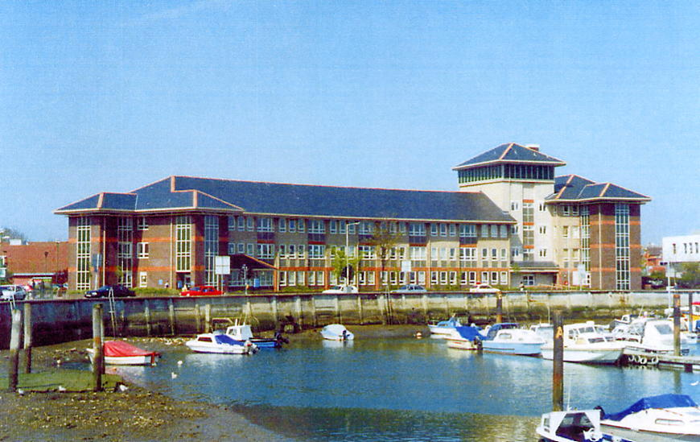

Westwey House, Weymouth

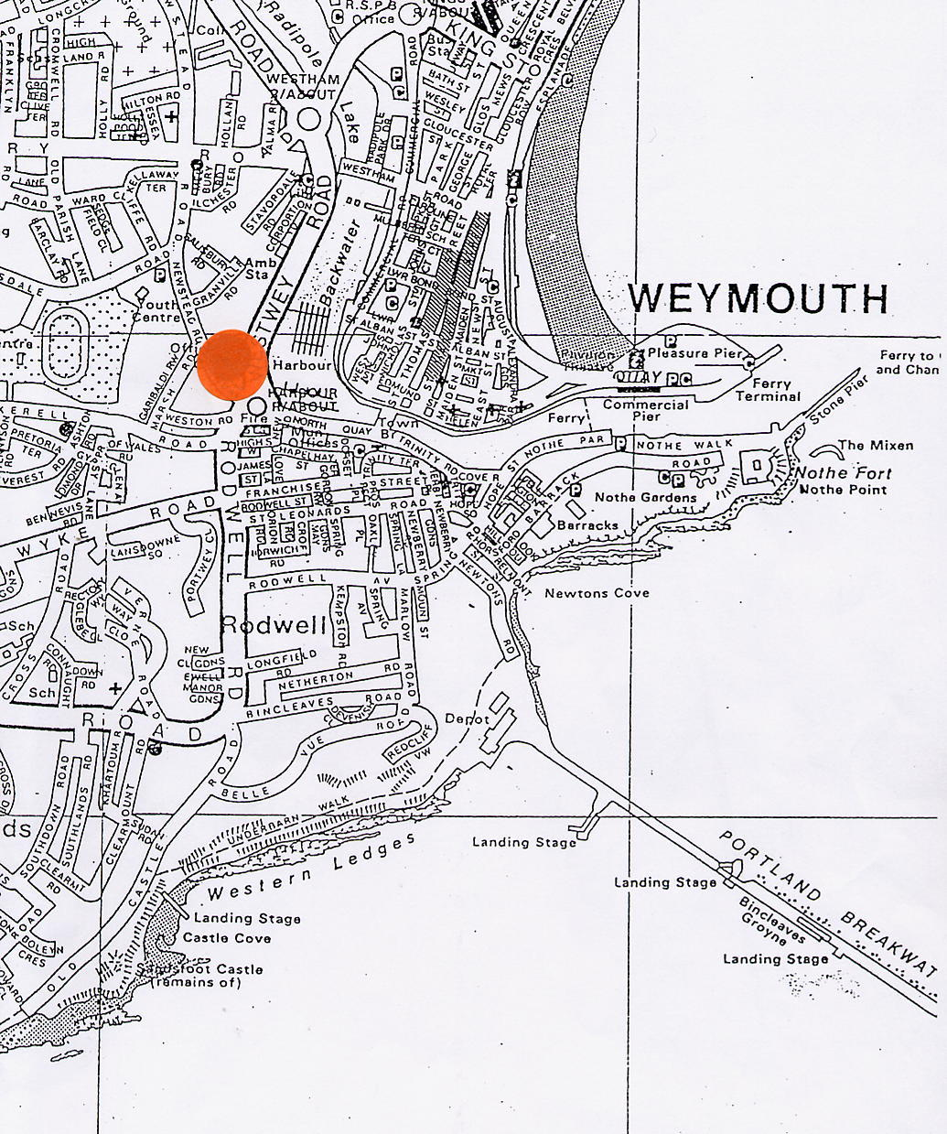

Westwey House, Weymouth

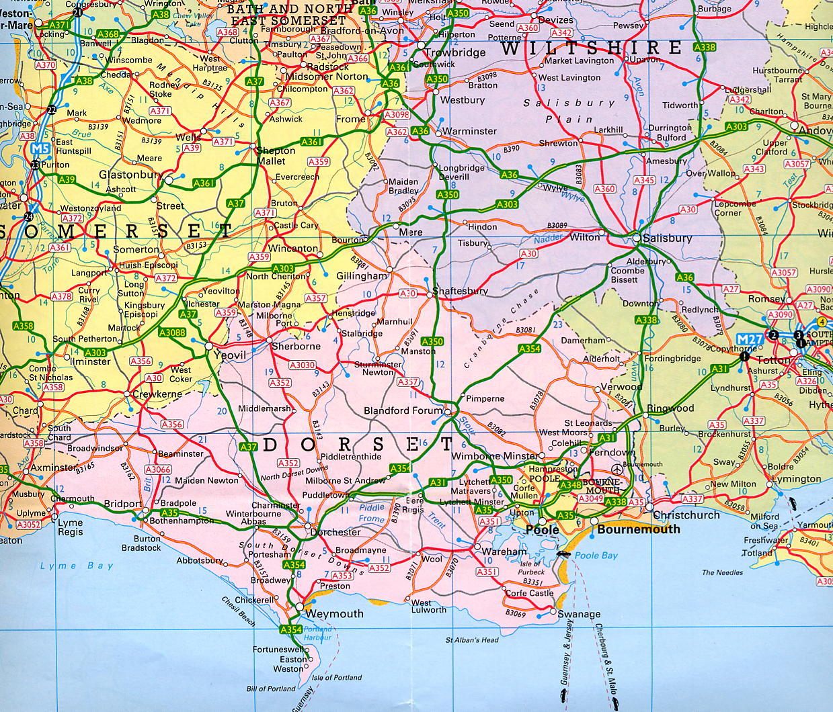

Westwey House, Weymouth

